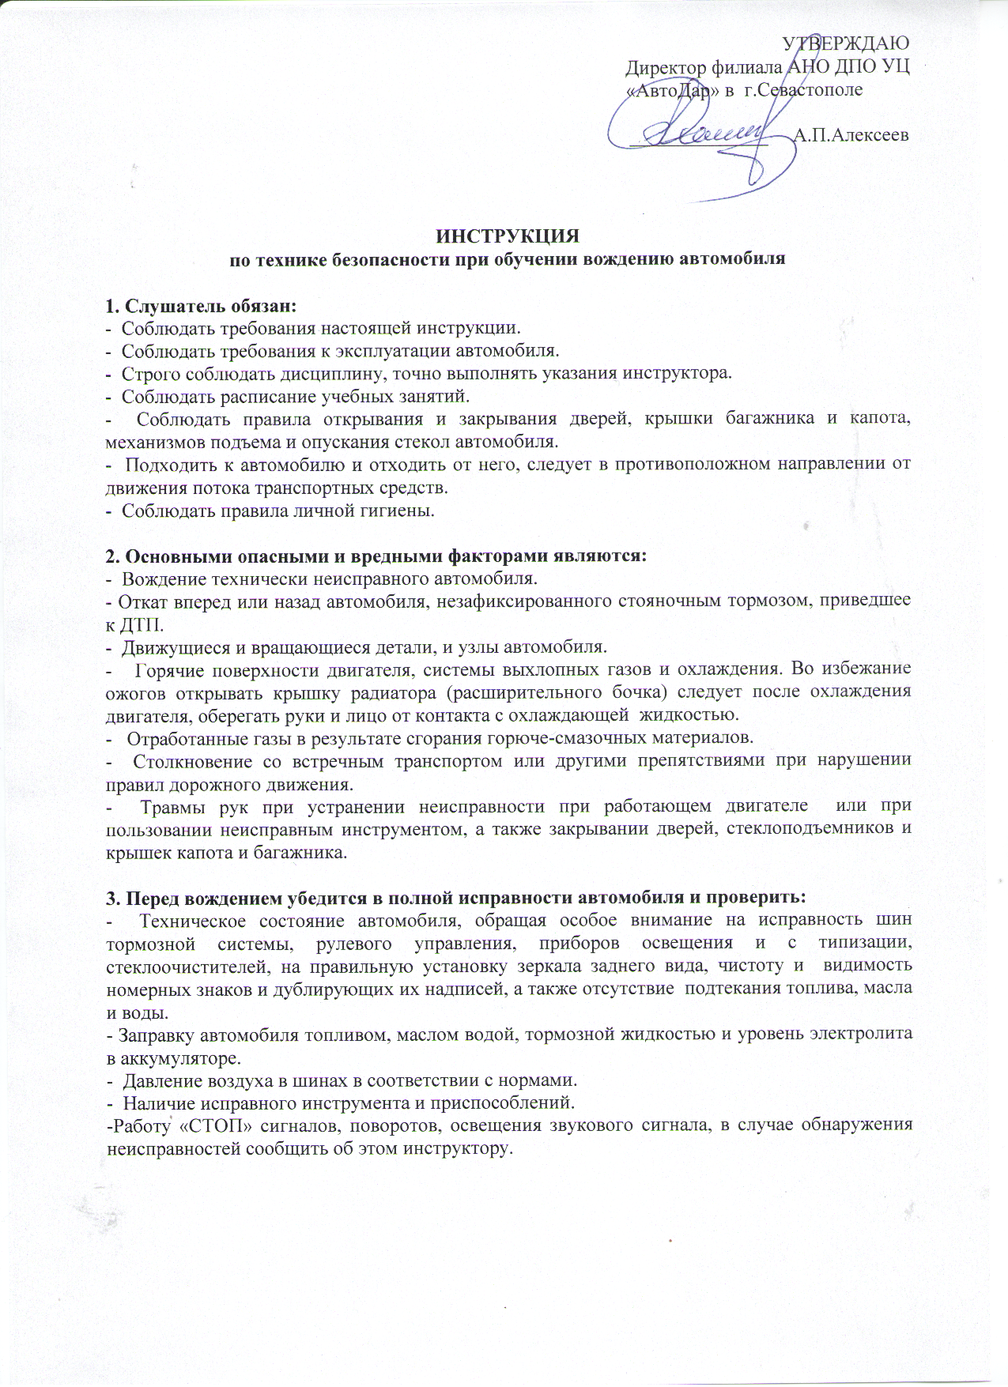

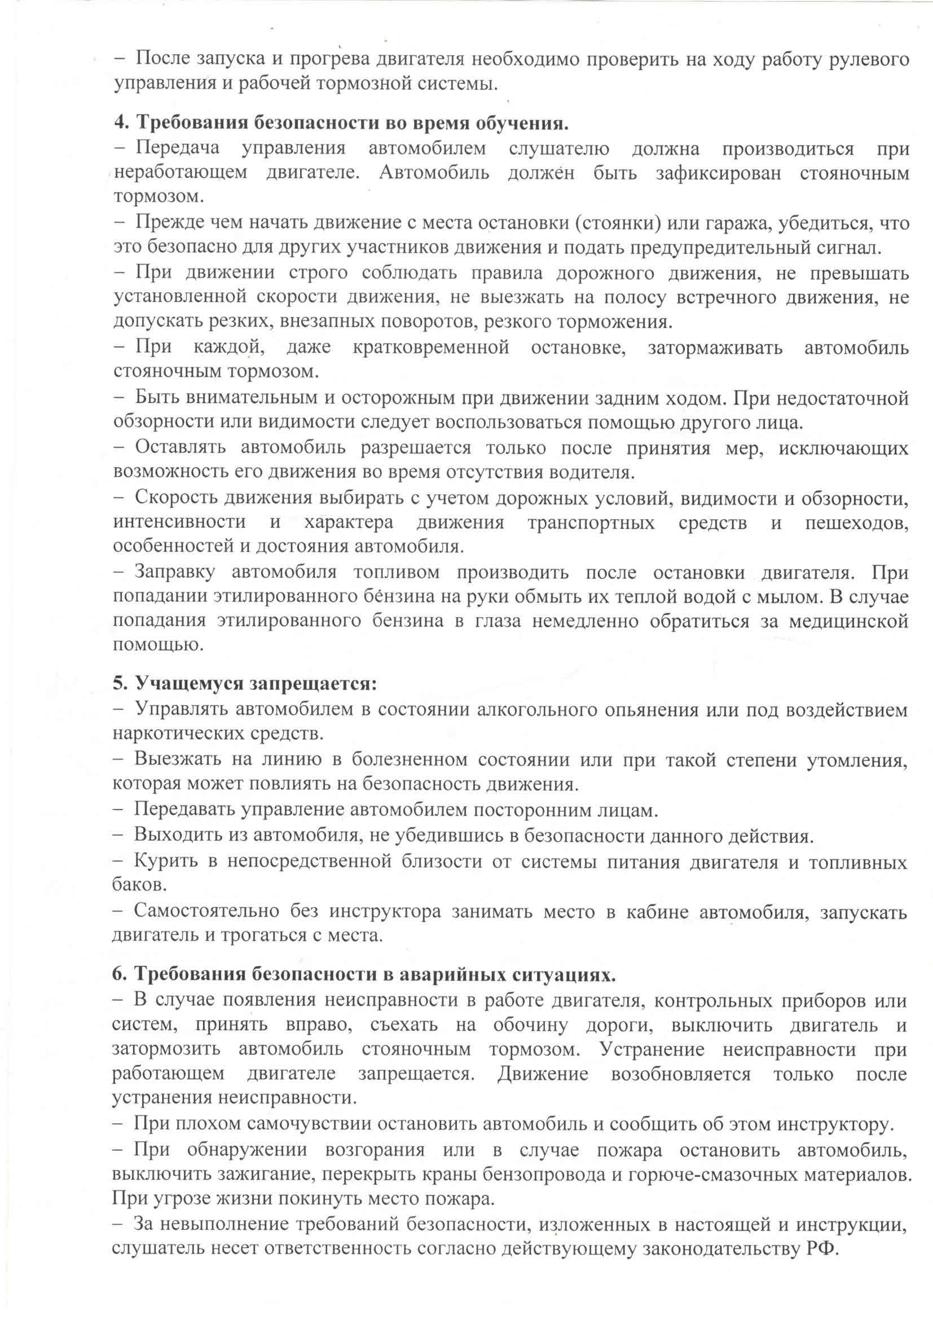

ознакомлен

__________________ _________________